Living in the digital age
The Human Race has witnessed several revolutions since it began thousands of years ago. The Stone, Bronze and Iron Ages saw mankind use the raw materials available to him to produce weapons and tools. Animals like the horse were captured, bred and domesticated. Natural resources were collected and building techniques developed.

The idea of the integrated circuit was conceived by Geoffrey Dummer (1909–2002), a radar scientist working for the Royal Radar Establishment of the British Ministry of Defence. Dummer presented the idea to the public at the Symposium on Progress in Quality Electronic Components in Washington, D.C. on 7 May 1952. He gave many symposia publicly to propagate his ideas and unsuccessfully attempted to build such a circuit in 1956.

A precursor idea to the IC was to create small ceramic squares (wafers), each containing a single miniaturized component. Components could then be integrated and wired into a bidimensional or tridimensional compact grid. This idea, which seemed very promising in 1957, was proposed to the US Army by Jack Kilby and led to the short-lived Micromodule Program (similar to 1951's Project Tinkertoy). However, as the project was gaining momentum, Kilby came up with a new, revolutionary design: the IC.

Jack Kilby's original integrated circuit
Newly employed by Texas Instruments, Kilby recorded his initial ideas concerning the integrated circuit in July 1958, successfully demonstrating the first working integrated example on 12 September 1958. In his patent application of 6 February 1959, Kilby described his new device as "a body of semiconductor material … wherein all the components of the electronic circuit are completely integrated." The first customer for the new invention was the US Air Force.

The Industrial Revolution
The Industrial Revolution of the 1900s saw the creation of an ‘iron horse’: the concept of using machines in place of humans for labour. The invention of the steam engine mobilized people and mechanized factories and farming. Railways, bridges and roads were built to accommodate the new machines.

The Industrial Revolution, which took place from the 18th to 19th centuries, was a period during which predominantly agrarian, rural societies in Europe and America became industrial and urban. Prior to the Industrial Revolution, which began in Britain in the late 1700s, manufacturing was often done in people’s homes, using hand tools or basic machines. Industrialization marked a shift to powered, special-purpose machinery, factories and mass production. The iron and textile industries, along with the development of the steam engine, played central roles in the Industrial Revolution, which also saw improved systems of transportation, communication and banking. While industrialization brought about an increased volume and variety of manufactured goods and an improved standard of living for some, it also resulted in often grim employment and living conditions for the poor and working classes.

The Electronic Revolution
In the 1950s, the electronic revolution of a post war world led to the age of the microchip. Electronics technology was now coupled with precision mechanical devises. Universities and military forces throughout the U.S. and Britain poured vast amounts of money and labour into the creation of what is now known as the Internet. New companies headed by scientists and funded by the U.S. government settled in an area of the Californian desert now known as Silicon Valley. The companies they founded are now household names in the fields of electronics and computing.
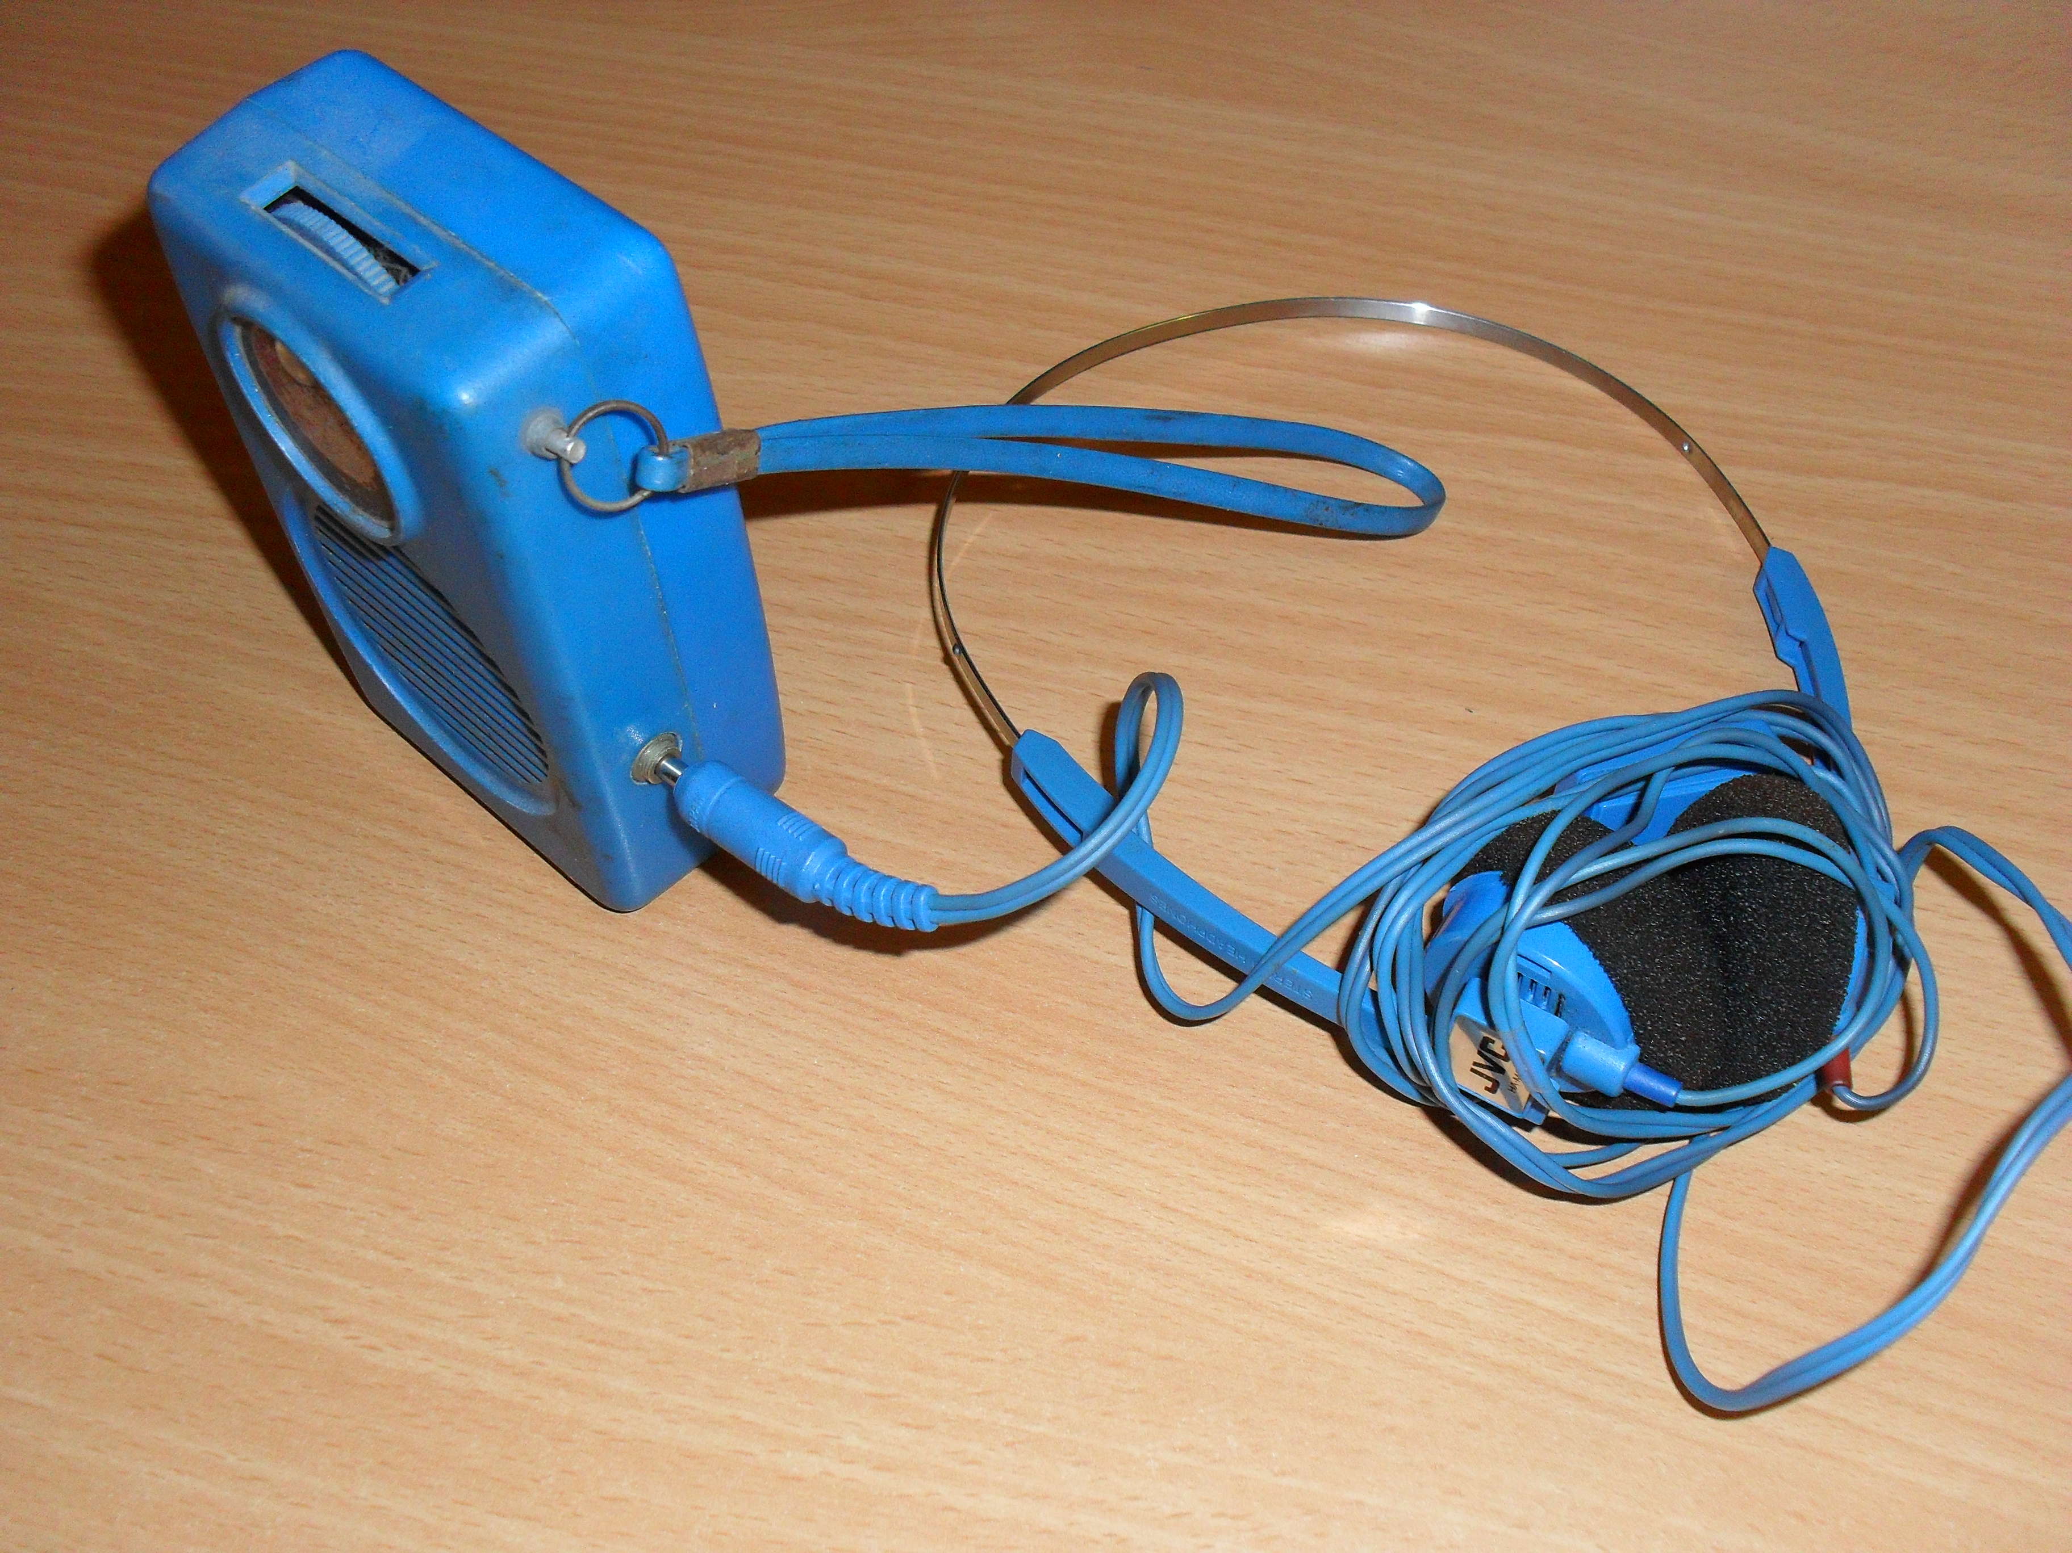

In 1968 I purchased a transistor radio, I drilled a hole in the side and plugged in a pair of headphones,
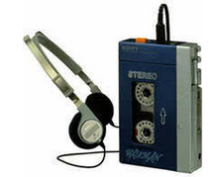
(see picture left) walking down the main street in Kensington, London I got many strange looks, particularly from a Japanese gentleman and I think he took my idea back to Japan, I think he worked for Sony!

New consumer markets were found for a range of sophisticated electronic devices. The business world saw a need for computers and their ability to control and manipulate millions of pieces of data. In the 1980s, large, expensive and complex business computers were reduced to a single unit, the personal computer.

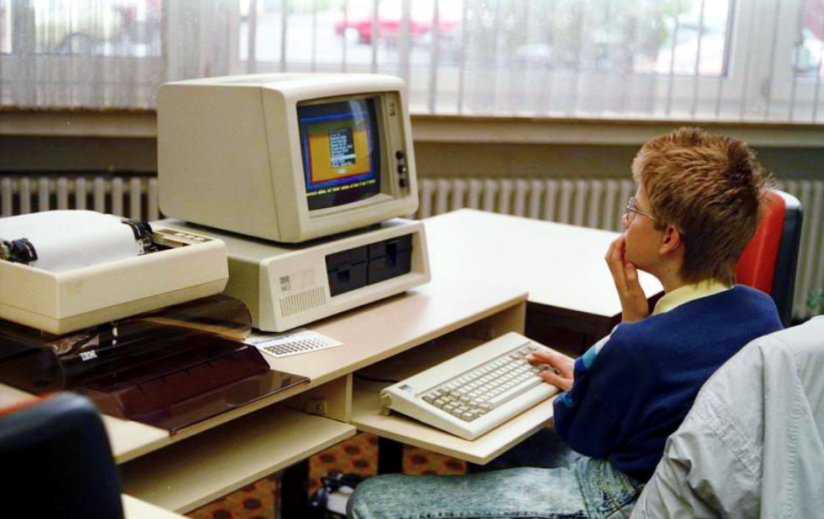

IBM Personal Computer XT in 1988 - The PC was an invention that dramatically changed not only a professional but also personal life.

The rise of the digital age
The focus had now changed from one of high tech electronics to that of language, a language that could be understood by a machine. The creation of programming languages and operating systems gave rise to the concept of artificial intelligence: machines that would not just do as instructed, but actually think for themselves.
With the rise of the machines, computers spread into every aspect of life. The development of home computing products, especially those which can process images, drove people into digital imaging.

Once the top secret domain of military strategists, satellite imagery moved from spying, to mapping and the prediction of weather. The advances in digital imaging technology made their way into the home as digital cameras, scanners and printers. Coupled with a booming interest in the Internet and the World Wide Web, the digital revolution had begun.

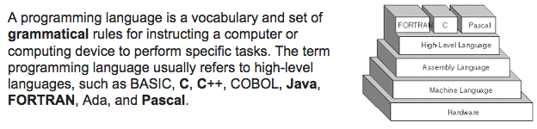

The impact of the Digital Revolution
Today, personal computing products are common and ever increasing. The benefits of digital information and the advances in communication networks have impacted on society as a whole.

The fields of communication and entertainment have enjoyed the greatest success, with consumer electronic devices driving the computing industry into the 21st century.

A computer is a device that can be instructed to carry out arbitrary sequences of arithmetic or logical operations automatically. The ability of computers to follow generalized sets of operations, called programs, enables them to perform an extremely wide range of tasks.

Such computers are used as control systems for a very wide variety of industrial and consumer devices. This includes simple special purpose devices like microwave ovens and remote controls, factory devices such as industrial robots and computer assisted design, but also in general purpose devices like personal computers and mobile devices such as smartphones. The Internet is run on computers and it connects millions of other computers using a language (HTML) Hypertext Markup Language.

Sample shown here

<!DOCTYPE html>
<html>
<body>

<p>The samp element represents output from a program or computing system:</p>

<p>If you input wrong value, the program will return <samp>Error!</samp></p>

</body>
</html>

However, not all of the impacts have been positive. Living in a digital world means information, and information in the wrong hands can have severe consequences. Identity theft, invasions of privacy and a network of individuals searching for ways to exploit the internet have forced changes in the way we live, digitally.


Need help just ask

